How to save your tree from Japanese Honeysuckle, Invasive Bittersweet and Asian Wisteria
(and from other invasive vines that wrap around or drape themselves over trees)
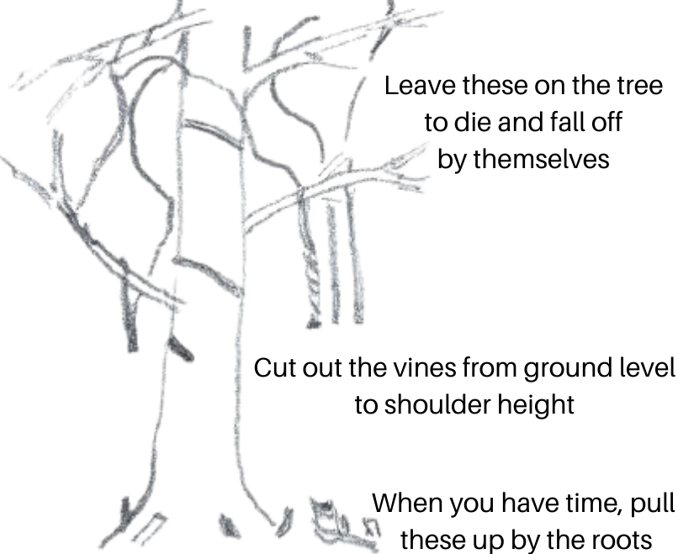
- Use garden clippers (or a saw for large vines) to cut the vines close to the ground.
- Cut them again around shoulder height and remove the vines in between. This makes it easy to see what you have done and keeps the vines from providing a ladder for new vines to grow up.
- Leave the rest of the vines on the tree. Trying to pull them off may hurt the tree and also could pull branches down onto your head.
- Congratulations - you have saved the tree! To keep the vines on the ground from growing back, pull them up by the roots.

Try not to accidentally cut any native vines, which don’t hurt the trees and which are an important food source for birds and other wildlife. Common examples are native grape vines, Greenbrier, and Trumpet Creeper For more information, see www.plantnovatrees.org/tree-rescuers-volunteer-program.

How to save your tree from Japanese Honeysuckle, Invasive Bittersweet and Asian Wisteria
(and from other invasive vines that wrap around or drape themselves over trees)
- Use garden clippers (or a saw for large vines) to cut the vines close to the ground.
- Cut them again around shoulder height and remove the vines in between. This makes it easy to see what you have done and keeps the vines from providing a ladder for new vines to grow up.
- Leave the rest of the vines on the tree. Trying to pull them off may hurt the tree and also could pull branches down onto your head.
- Congratulations - you have saved the tree! To keep the vines on the ground from growing back, pull them up by the roots.

Try not to accidentally cut any native vines, which don’t hurt the trees and which are an important food source for birds and other wildlife. Common examples are native grape vines, Greenbrier, and Trumpet Creeper For more information, see www.plantnovatrees.org/tree-rescuers-volunteer-program.

How to save your tree from English Ivy or Winter Creeper
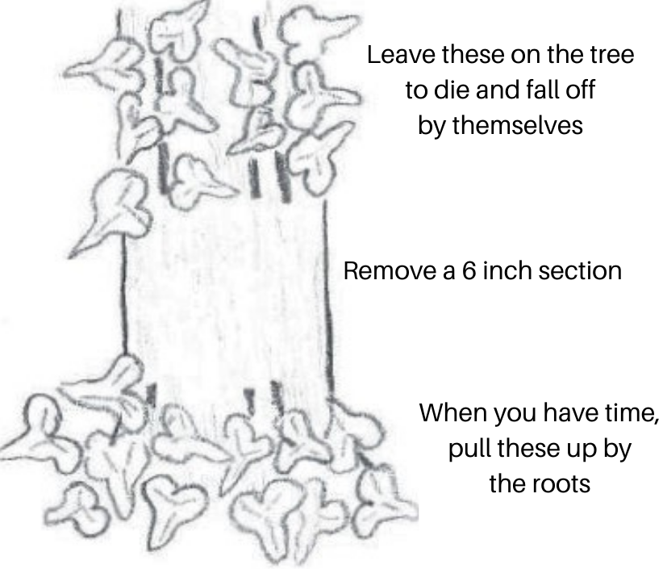
- Use garden clippers (or a saw for large vines) to cut the vines at the bottom in a ring around the entire trunk of the tree. Be very careful not to cut the bark of the tree. You might find it easier to scrape off the leaves first with a saw so you can see the stems better.
- Cut them again around six inches higher and remove the vines in between the two cuts. A screwdriver might help.
- When removing the six inch section of vines in between. Be careful not to pull off the tree’s bark with it.
- Leave the rest of the vines on the tree. Trying to pull them off may hurt the tree and also could pull branches down onto your head.
- Congratulations - you have saved the tree! To keep the vines on the ground from growing back, pull them up by the roots.

Thick English Ivy and Wintercreeper stems are hairy, but so are those of Poison Ivy! Poison Ivy loses its leaves in the winter, and English Ivy and Wintercreeper keep them, but sometimes more than one vine may be climbing on the same tree, so be careful!
Poison Ivy is a native vine which is valuable for wildlife and does not damage trees, but you might not want it in your yard. Try not to accidentally cut any other native vines such as Virginia Creeper, which also sticks to the trunk of trees. For more information, see www.plantnovatrees.org/tree-rescuers-volunteer-program.

How to save your tree from English Ivy or Winter Creeper
- Use garden clippers (or a saw for large vines) to cut the vines at the bottom in a ring around the entire trunk of the tree. Be very careful not to cut the bark of the tree. You might find it easier to scrape off the leaves first with a saw so you can see the stems better.
- Cut them again around six inches higher and remove the vines in between the two cuts. A screwdriver might help.
- Remove the six inch section of vines in between. Be careful not to pull off the tree’s bark with it.
- Leave the rest of the vines on the tree. Trying to pull them off may hurt the tree and also could pull branches down onto your head.
- Congratulations - you have saved the tree! To keep the vines on the ground from growing back, pull them up by the roots.

Thick English Ivy and Wintercreeper stems are hairy, but so are those of Poison Ivy! Poison Ivy loses its leaves in the winter, and English Ivy and Wintercreeper keep them, but sometimes more than one vine may be climbing on the same tree, so be careful!
Poison Ivy is a native vine which is valuable for wildlife and does not damage trees, but you might not want it in your yard. Try not to accidentally cut any other native vines such as Virginia Creeper, which also sticks to the trunk of trees. For more information, see www.plantnovatrees.org/tree-rescuers-volunteer-program.

